**User manual of the ExtractValleyFloorTool plug-in**

**1 Develop environment and basin information**

**Coding**: Microsoft Visual Studio 2010, C#

**Operating system:** Windows 7

**GIS Platform:** ArcGIS 10.1

**Hardware required:** meet ArcGIS 10.1

**Developer**: Yinjun Zhao, Jiaxu Li

**Contact address**: 175 mingxiu east st, Nanning, China, Guangxi Teachers Education University, Zip 530001.

**Name of Code**: ValleyBottomLineControl

**First vision**: 2017.11

**Program size**: 58 k

**The email of contacting or accessing source code**: crpp0104@163.com

**2 Setup and Deployment**

**The process of setup and deployment as follows:**

**Stage 1：**

**(1) Double click the plug-in (**ExtractValleyFloorTool**.esriAddIn) to install;**

**(2) Click the Install Add-in button**

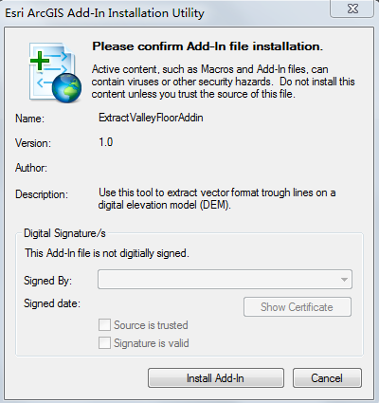

Figure 1 Setup dialogue

**Stage 2:**

(1) Open ArcGIS

(2) In Figure 2, Successively click 1,2,3, then drag 4 to toolbar of ArcGIS.



Figure 2 Add in the control

**3 User manuals**

(1) Click C:\Users\Win7\AppData\Roaming\Tencent\Users\19612986\QQ\WinTemp\RichOle\1F4OUAON8SE84UH~P0]L[]W.png to open Figure 3

(2) Input parameters.



Figure 3 The main interface of ValleyBottomLine

(3) Click ok button.